MasrRetail ETL
Project Documentation
Grocery Price Analysis in Egypt

Team Members:
Reem Yasser Mohamed
Reem Osama Mohamed
Mai Ahmed Mostafa
Joussiana Atef Marzouk

Year: 2026

Table of Contents
1. Project Planning & Management 3
1.1 Introduction 3
1.2 Problem Statement 3
1.3 Motivation 4
1.4 Project Overview 4
1.5 Objectives 5
1.6 Scope and Limitations 5
1.7 Project Plan 6
1.8 Task Assignment & Roles 6
1.9 Risk Assessment & Mitigation Plan 7
1.10 KPIs (Key Performance Indicators) 7
2. Literature Review 8
2.1 Retail Price Analysis Research 8
2.2 ETL Frameworks and Data Pipeline Design 9
2.3 Price Comparison Systems 9
3. Requirements Gathering 11
3.1 Stakeholder Analysis 11
3.2 User Stories & Use Cases 12
3.3 Functional Requirements 12
3.4 Non-Functional Requirements 13
4. System Analysis & Design 14
4.1 Problem Statement & Objectives 14
4.2 Use Case Diagram & Descriptions 15
4.3 Software Architecture 15
4.4 Database Design & Data Modelling 16
4.4.1 ER Diagram 16
4.4.2 Logical & Physical Schema 16
4.5 Data Flow & System Behaviour 19
4.5.1 Sequence Diagram — ETL Pipeline Execution 19
4.5.2 Activity Diagram — ETL Pipeline Workflow 19
4.5.3 Class Diagram 20
4.8 Testing & Validation 21
4.9 Deployment Strategy 21
References 21

1. Project Planning & Management

1.1 Introduction
The Egyptian retail sector has undergone significant transformation over the past decade, driven by rapid urbanization, currency fluctuations, and the expansion of large supermarket chains across the country's 27 governorates. Despite these developments, consumers, researchers, and policymakers continue to face a critical lack of structured, accessible data on how grocery prices behave across different locations, retailers, and time periods. Understanding the true cost of everyday goods and how that cost evolves under inflationary pressure remains a challenge that existing tools and platforms have not adequately addressed in the Egyptian context.

MasrRetail ETL is a data engineering and analytics project designed to bridge this gap. By systematically collecting, processing, and analyzing grocery price data from major Egyptian supermarket chains and integrating it with official Consumer Price Index (CPI) statistics published by the Central Agency for Public Mobilization and Statistics (CAPMAS), the project creates a unified analytical platform that makes pricing dynamics transparent and measurable. The result is a system that empowers stakeholders at every level from individual consumers seeking the best value to economists tracking food inflation with clear, evidence-based insights into the Egyptian grocery market.

1.2 Problem Statement
Egypt has experienced considerable inflationary pressure in recent years, with food and beverage prices among the most volatile components of household expenditure. The Egyptian pound's devaluation cycles, combined with disruptions in global food supply chains, have had a direct and disproportionate impact on the cost of essential grocery items. Yet despite the significance of this issue, there is currently no publicly accessible, structured system that connects official inflation data with actual product-level prices observed across supermarket chains at a national scale.

Consumers lack the tools to make informed comparisons between retailers or understand how prices in their governorate compare to the national average. Researchers and analysts who wish to study retail price dynamics are forced to rely on aggregated CPI figures that mask product-level and regional variation. Supermarket operators have limited visibility into how their pricing positions them relative to competitors in a systematic, data-driven way. This absence of structured retail price intelligence represents a meaningful gap in Egypt's data ecosystem — one that MasrRetail ETL is specifically designed to fill.

1.3 Motivation
The motivation for this project stems from both practical necessity and academic relevance. From a practical standpoint, food affordability is a matter of direct concern for Egyptian households, where food expenditure constitutes a substantial portion of total household spending. A system that makes grocery price trends visible and comparable has immediate, real-world value for consumers, civil society organizations, and government agencies tasked with monitoring living standards.

From an academic and technical standpoint, the project addresses an under-researched domain. While ETL systems and retail analytics are well-established fields globally, their application to Egyptian and broader MENA retail data remains sparse in published literature. Building a pipeline that integrates heterogeneous data sources, scraped retail data, structured CPI reports, and geographical metadata and transforms them into a coherent analytical database presents genuine technical challenges that make this project a meaningful contribution to both data engineering practice and regional economic research.

1.4 Project Overview
MasrRetail ETL is a data pipeline and analytics system focused on the Egyptian grocery retail market. The system extracts price data from major supermarket chains operating across Egypt, including national hypermarket networks and regional chains, and combines this data with official CPI statistics sourced from CAPMAS. This combined dataset is then processed through a structured ETL pipeline that cleans, standardizes, and loads the data into a relational database designed for analytical querying. The final layer of the system presents the processed data through an interactive visualization dashboard that enables users to explore price trends over time, compare prices across retailers and product categories, and examine geographical price variation across Egypt's governorates. The project covers the full data lifecycle from raw source to visual insight, making it both a technical data engineering exercise and a substantive contribution to understanding retail price dynamics in Egypt.

1.5 Objectives
The objectives of this project are to:
1. Collect grocery price data from at least three major Egyptian supermarket chains operating across multiple governorates.
2. Integrate official Consumer Price Index data published by CAPMAS to enable inflation-adjusted price analysis.
3. Design and implement a robust ETL pipeline that extracts, validates, transforms, and loads data into a structured relational database.
4. Build a normalized database that supports efficient analytical querying across products, supermarkets, locations, and time periods.
5. Develop an interactive visualization dashboard that presents price trends, cross-retailer comparisons, and geographical price distribution.
6. Enable data-driven insights into grocery price inflation, regional price disparities, and retail market behavior in Egypt.

1.6 Scope and Limitations
This project focuses on the collection, processing, and analysis of grocery price data from major Egyptian supermarket chains, covering essential product categories including dairy, bread, meat, vegetables, and packaged goods. The analytical scope spans multiple Egyptian governorates and incorporates official CPI data to support inflation-adjusted comparisons over a multi-year period.

The project does not extend to real-time price monitoring, live integration with retailer systems, or the analysis of informal market or street vendor pricing. Data collection relies on publicly available sources and structured imports rather than on-site surveys or proprietary retailer data feeds. The depth and accuracy of analysis is therefore dependent on the availability and consistency of source data. Initial implementation focuses on batch-processed price records at the product and chain level rather than individual branch-level granularity for all locations, and the system is designed as a scalable foundation that can be extended in future work to incorporate additional retailers, product categories, and real-time data pipelines.

1.7 Project Plan
The project is structured into eight sequential phases. Each phase has defined tasks, a time allocation, and a concrete deliverable that marks its successful completion.

Phase | Tasks | Duration | Deliverable
Phase 1 | Project Planning, Scope Definition, Stakeholder Analysis | 2 weeks | Project Proposal & Plan
Phase 2 | Literature Review, Existing Systems Analysis | 1 week | Literature Review Report
Phase 3 | Requirements Gathering, Stakeholder Interviews | 1 week | Requirements Document
Phase 4 | System Analysis, Database Design, Data Flow, UI/UX Mockups | 2 weeks | System Design Document
Phase 5 | ETL Development, Database Implementation, Data Loading | 3 weeks | Functional ETL Pipeline
Phase 6 | Analysis Dashboards, Visualization Development | 2 weeks | Dashboard & Reports
Phase 7 | Testing, Validation, QA, Bug Fixes | 1 week | Test Reports
Phase 8 | Final Documentation, Presentation, Deployment | 1 week | Final Report & Deployment

1.8 Task Assignment & Roles
The following table defines the responsibilities of each team member across the project phases, ensuring clear ownership and accountability for all deliverables.

Team Member | Primary Role | Responsibilities
Reem Yasser Mohamed | Project Manager & ETL Lead | Project planning, timeline management, ETL pipeline architecture and development, risk tracking
Reem Osama Mohamed | Database Engineer | Database schema design, PostgreSQL implementation, query optimization, data integrity validation
Mai Ahmed Mostafa | Data Analyst & Visualization | Dashboard development, chart design, CPI integration analysis, reporting layer
Joussiana Atef Marzouk | Documentation & QA Lead | Technical documentation, requirements gathering, testing coordination, literature review

1.9 Risk Assessment & Mitigation Plan
The following risk register identifies the key risks facing the MasrRetail ETL project, evaluates their likelihood and potential impact, and outlines the mitigation strategy for each.
Risk | Mitigation Strategy
Inconsistent or missing price data from supermarkets | Use multiple overlapping data sources; implement fallback imputation for missing values
Changes in CAPMAS data format or availability | Cache historical datasets locally; monitor source regularly; maintain format adapters
ETL pipeline performance issues with large datasets | Implement batch processing, database indexing, and query optimization
Scope creep beyond grocery sector | Strict change control process; weekly scope reviews with team
Team resource unavailability | Cross-training across roles; comprehensive task documentation for handover
Database corruption from malformed source data | Validation gates at every ETL stage; automated integrity checks post-load
Dependency tool deprecation or breaking changes | Pin all library versions; maintain a tested requirements.txt lockfile

1.10 KPIs (Key Performance Indicators)

KPI | Description
Data Accuracy Rate | Percentage of loaded records passing all validation rules
ETL Pipeline Runtime | Time to complete a full dataset refresh cycle
Dashboard Load Time | Time for any dashboard page to fully render
System Uptime | Availability of the visualization dashboard during working hours
Data Coverage | Number of supermarket chains with active price data
Historical Depth | Years of price data available for trend analysis
Rejection Rate | Percentage of raw records rejected due to quality failures

2. Literature Review
The literature review examines existing research, methodologies, and systems relevant to retail price analysis, ETL frameworks, and consumer price tracking. This review provides a theoretical foundation for the MasrRetail ETL system and identifies gaps in current approaches that this project addresses. All cited sources are listed in the Harvard reference list at the end of this document.

2.1 Retail Price Analysis Research
Academic research on retail price dynamics has consistently highlighted the importance of granular, store-level data for understanding market behavior. Cavallo and Rigobon (2016) demonstrated through the Billion Prices Project at MIT that web-scraped retail prices can serve as high-frequency proxies for official CPI measurements, showing strong correlation with government-published inflation statistics. This foundational insight directly motivates the data collection methodology of the MasrRetail ETL system.

Research in emerging market contexts, including Egypt and comparable Middle Eastern economies, indicates that price dispersion across retail formats is particularly significant due to supply chain fragmentation (World Bank, 2019). The Egyptian context presents additional challenges including seasonal agricultural price volatility, currency fluctuation effects on imported goods, and geographical disparities in retail infrastructure between greater Cairo and rural governorates. Abdelfattah and Hassan (2021) noted that food price inflation in Egypt disproportionately affects lower-income households, reinforcing the social value of transparent retail price monitoring systems.

2.2 ETL Frameworks and Data Pipeline Design
Modern ETL literature emphasizes the shift toward ELT (Extract, Load, Transform) patterns enabled by cloud data warehouses (Kimball and Caserta, 2004). However, for this project's scope and infrastructure constraints, a classical ETL approach remains appropriate. Inmon (2005) established key principles of data warehouse design that underpin this project's architecture, including the separation of staging, integration, and reporting layers to ensure data quality and auditability.

Vassiliadis (2009) conducted a comprehensive survey of ETL processes, emphasizing that 60–80% of ETL development effort typically relates to data cleaning and validation — a finding that has directly informed the resource allocation in this project's development phase. For this project, a simpler approach is adopted: a single pandas-based Python script replaces the orchestration layer entirely, following the principle that the simplest solution adequate for the project scale is the best solution.

2.3 Price Comparison Systems
Existing commercial price comparison systems such as PriceRunner in Europe and Jcomparing in Egypt provide consumer-facing product comparisons but do not perform longitudinal trend analysis or CPI integration (Jcomparing, 2024). Academic systems developed for economic research, such as those built by the World Bank Food Price Watch programme, employ structured data collection from national statistical agencies combined with market surveys (World Bank, 2022).

The gap this project addresses is the integration layer: no existing publicly accessible system combines official CPI data with actual product-level supermarket prices in Egypt within a unified structured database and visual reporting layer. The MasrRetail ETL system is specifically designed to fill this gap.

3. Requirements Gathering
Requirements gathering captures the needs, expectations, and constraints of all project stakeholders. The process involved structured interviews with potential users including market researchers, consumer advocacy analysts, and retail operations staff, supplemented by review of comparable systems. Requirements are categorized as functional (what the system does) and non-functional.

3.1 Stakeholder Analysis
The following stakeholder groups were identified and analyzed for the MasrRetail ETL project. Each group has distinct needs that have been mapped to specific system requirements.

Stakeholder | Role | Primary Need
Market Researchers & Economists | Primary analytical users | Historical trend data, inflation-adjusted comparisons, exportable datasets
Consumer Advocacy Groups | Secondary users | Regional price disparities, affordability metrics for essential items
Retail Chain Analysts | Secondary users | Competitive pricing benchmarks across supermarket chains
Government / Policy Makers | Tertiary users | Aggregated food price trends by governorate for policy decisions
System Admins & Developers | Internal operators | Pipeline maintenance tools, monitoring dashboards, error logs

3.2 User Stories & Use Cases
User stories describe system interactions from the perspective of end users in a structured format: As a [user type], I want to [action], so that [benefit].

User Story | Acceptance Criteria
As a researcher, I want to view price trends for a specific product over the past year, so that I can identify seasonal pricing patterns. | Line chart renders for any product with date range selector; data accurate to within 1 day
As a consumer, I want to compare the price of milk across all tracked supermarkets, so that I can identify the cheapest option near me. | Comparison table shows all chains side-by-side with lowest price highlighted in green
As a policy analyst, I want to filter price data by governorate, so that I can assess regional food affordability. | All views support governorate multi-select filter; data updates within 3 seconds
As a data analyst, I want to export price data to CSV, so that I can perform my own statistical analysis. | Every table includes a CSV download button producing clean, header-labelled output
As a system admin, I want to view ETL pipeline run logs, so that I can identify and resolve data loading errors. | Pipeline runs table shows timestamp, record counts, rejection count, and status per run
As a researcher, I want to overlay CPI data on a product price chart, so that I can compare nominal and real price changes. | CPI overlay toggle available on trend chart; indexed to base year selected by user

3.3 Functional Requirements
Requirement
The system shall extract grocery price data from at least three major Egyptian supermarket chains.
The system shall integrate official CPI data from CAPMAS into the analytical database.
The ETL pipeline shall clean, validate, and standardize all incoming data before loading.
The database shall store product, supermarket, price, and governorate entities with defined relationships.
The system shall support price comparison queries across supermarkets for the same product.
The system shall support time-series queries showing price changes over configurable date ranges.
The system shall support geographical filtering by Egyptian governorate.
The visualization layer shall provide time-series trend charts for selected products and categories.
The system shall allow filtering by product category, supermarket chain, and date range.
The ETL pipeline shall log all data quality issues
The system shall provide exportable reports in CSV format for downstream analysis.

3.4 Non-Functional Requirements
Requirement
The ETL pipeline shall process and load a full dataset
The database shall support concurrent queries
The system shall achieve high data accuracy after ETL validation processing.
All user-facing dashboard pages shall load under normal operating conditions.
The system shall be deployable on standard commodity hardware
The ETL pipeline shall be re-runnable without duplicating records in the target database.
The user interface shall be operable by non-technical users with no prior database or coding knowledge.
The system shall provide data source attribution and methodology documentation accessible to all users.
All database credentials and API keys shall be stored securely

4. System Analysis & Design
The system analysis and design phase translates the gathered requirements into concrete technical specifications.

4.1 Problem Statement & Objectives
The core problem this system addresses is the absence of a unified, structured platform that integrates supermarket-level grocery prices with official inflation data in Egypt. Existing tools either provide real-time snapshots without historical depth or provide aggregated CPI statistics without product-level resolution. This gap prevents meaningful analysis of how inflation affects specific product categories, how prices vary between retailers, and how different Egyptian governorates experience food price changes differently.

The MasrRetail ETL system addresses this problem by building a lightweight but complete data pipeline: price data is manually collected from supermarket apps into CSV files, cleaned and loaded by a Python script, stored in a SQLite database, and displayed through a dashboard. The system enables product-level price trend analysis across multiple months, cross-chain price comparisons, and governorate-level filtering.

4.2 Use Case Diagram & Descriptions
The MasrRetail ETL system has three primary actors: the End User (researcher, consumer, or analyst accessing the dashboard), the System Administrator (responsible for ETL operations and monitoring), and the ETL Pipeline (automated system actor performing data extraction and loading). The diagram below should be inserted by the team.

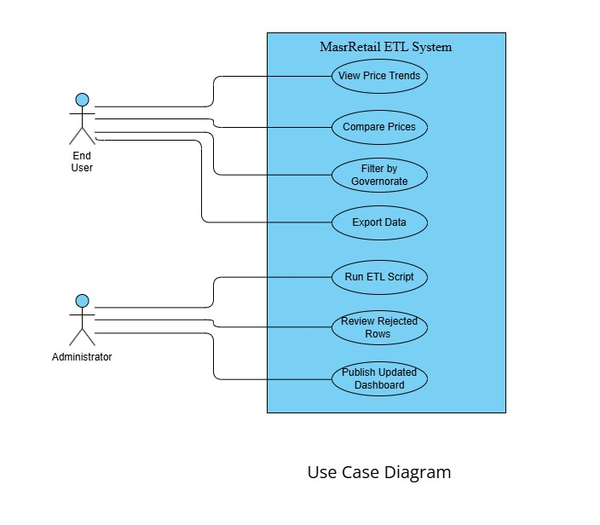

4.3 Software Architecture
The MasrRetail ETL system uses a simple two-script architecture that handles all data collection, cleaning, and loading and handles all visualization and user interaction. Both share a single SQLite database file. This separation ensures that updating data never requires touching dashboard code. The four logical layers are:

- Data Source Layer — External sources: supermarket websites, manually curated CSV price files, and the CAPMAS CPI statistical portal. This layer is read-only from the system's perspective.
- ETL Pipeline Layer — A single Python script that reads CSVs with pandas, cleans and validates data, and writes to the SQLite database.
- Data Storage Layer — A SQLite database file with three tables: products, supermarkets, and prices.
- Presentation Layer — A dashboard that shows the output

4.4 Database Design & Data Modelling

4.4.1 ER Diagram
The Entity-Relationship Diagram illustrating the full database structure, including all entities, attributes, primary keys, foreign keys, and cardinality relationships, is presented below. The ERD was designed using a star schema with PRICE_RECORDS as the central fact table.

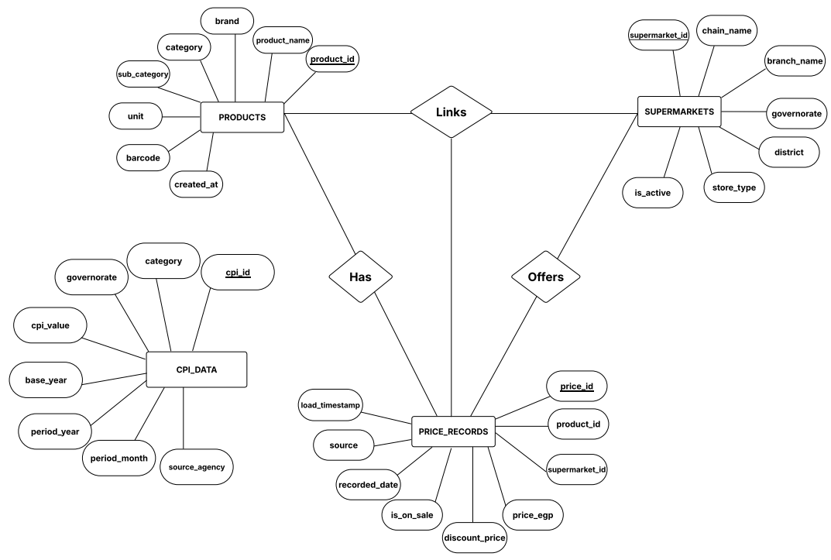

4.4.2 Logical & Physical Schema
The schema is implemented directly in SQLite using pandas to_sql() and standard SQL CREATE TABLE statements. The three tables below define the complete database structure.

Entity: PRODUCTS
Field Name | Data Type | Constraints | Description
product_id | SERIAL | PRIMARY KEY | Unique product identifier
product_name | VARCHAR(200) | NOT NULL | Full product name as listed
brand | VARCHAR(100) | NULLABLE | Brand name if available
category | VARCHAR(100) | NOT NULL | Product category (e.g., Dairy, Meat)
sub_category | VARCHAR(100) | NULLABLE | Sub-category for finer grouping
unit | VARCHAR(50) | NOT NULL | Unit of measurement (kg, litre, piece)
barcode | VARCHAR(50) | UNIQUE, NULLABLE | EAN/UPC barcode if available
created_at | TIMESTAMP | DEFAULT NOW() | Record creation timestamp

Entity: SUPERMARKETS
Field Name | Data Type | Constraints | Description
supermarket_id | SERIAL | PRIMARY KEY | Unique supermarket identifier
chain_name | VARCHAR(100) | NOT NULL | Supermarket chain name (e.g., Carrefour)
branch_name | VARCHAR(150) | NULLABLE | Specific branch name if applicable
governorate | VARCHAR(100) | NOT NULL | Egyptian governorate of the branch
district | VARCHAR(100) | NULLABLE | District or area within governorate
store_type | VARCHAR(50) | NOT NULL | Hypermarket, Supermarket, or Minimarket
is_active | BOOLEAN | DEFAULT TRUE | Indicates if branch is currently active

Entity: PRICE_RECORDS
Field Name | Data Type | Constraints | Description
price_id | BIGSERIAL | PRIMARY KEY | Unique price observation identifier
product_id | INTEGER | FK → products | Reference to product
supermarket_id | INTEGER | FK → supermarkets | Reference to supermarket branch
price_egp | NUMERIC(10,2) | NOT NULL, CHECK > 0 | Price in Egyptian Pounds
discount_price | NUMERIC(10,2) | NULLABLE | Discounted/promotional price if active
is_on_sale | BOOLEAN | DEFAULT FALSE | Promotional price flag
recorded_date | DATE | NOT NULL | Date price was observed/collected
source | VARCHAR(100) | NOT NULL | Data source identifier
load_timestamp | TIMESTAMP | DEFAULT NOW() | ETL load timestamp

Entity: CPI_DATA
Field Name | Data Type | Constraints | Description
cpi_id | SERIAL | PRIMARY KEY | Unique CPI record identifier
category | VARCHAR(100) | NOT NULL | CPI product category from CAPMAS
governorate | VARCHAR(100) | NULLABLE | Governorate if regional CPI available
cpi_value | NUMERIC(8,2) | NOT NULL | CPI index value
base_year | INTEGER | NOT NULL | CPI base year (e.g., 2020)
period_year | INTEGER | NOT NULL | Year of observation
period_month | INTEGER | NOT NULL, CHECK 1-12 | Month of observation
source_agency | VARCHAR(100) | DEFAULT 'CAPMAS' | Publishing agency

4.5 Data Flow & System Behaviour

4.5.1 Sequence Diagram — ETL Pipeline Execution
The ETL execution sequence diagram illustrates the interaction between the Team Member (who runs the script), the etl.py script, pandas, and the SQLite database. The sequence begins with the team member running python etl.py in the terminal, proceeds through CSV reading → data cleaning → validation → SQLite write, and concludes with the console summary line and rejected_rows.csv update.
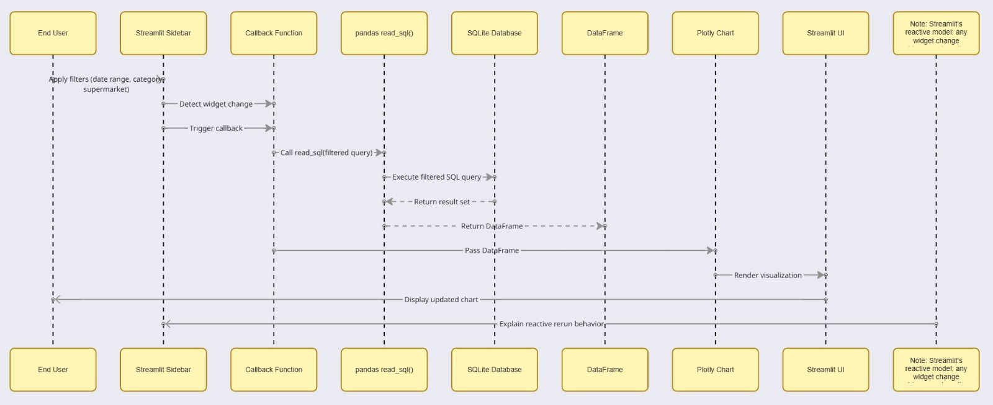

4.5.2 Activity Diagram — ETL Pipeline Workflow
The activity diagram maps the workflow of a single etl.py run from start to finish. It includes decision branches for validation failures (route to rejected_rows.csv vs. proceed to loading) and for file read errors (print error message vs. continue with next file). The workflow ends at either a success state (summary printed, database updated) or a partial failure state (some rows rejected, rest loaded).
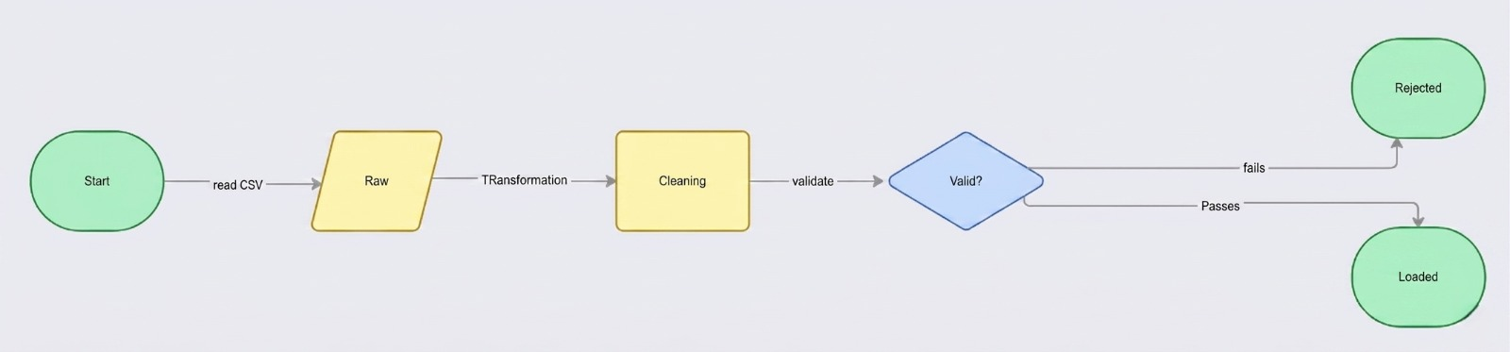

4.5.3 Class Diagram
The class diagram defines the structure of the two main scripts. For etl.py the key functions are: load_csv(filepath) → DataFrame, clean_prices(df) → DataFrame, standardize_categories(df, mapping) → DataFrame, validate_records(df) → (valid_df, rejected_df), and load_to_sqlite(df, table, db_path). For app.py the key functions are: get_prices(filters) → DataFrame, get_comparison(product, date) → DataFrame, get_trend(product, start, end) → DataFrame, and render_chart(df, chart_type) → Plotly Figure. These functions have no class wrapper — they are plain Python functions, which is appropriate for a script of this scale.

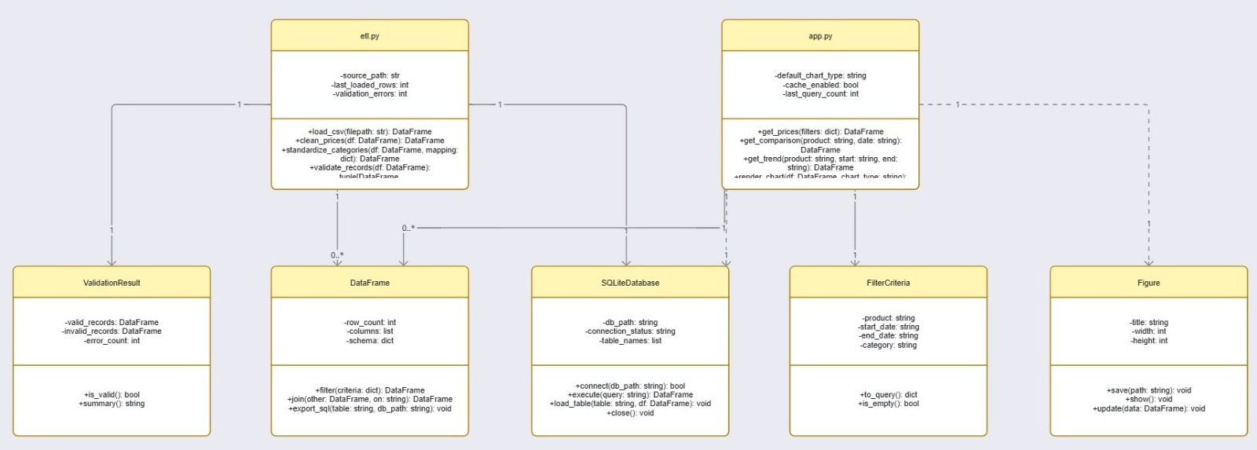

4.8 Testing & Validation
The MasrRetail ETL system uses a three-tier testing approach to make sure data flows cleanly from source to dashboard. Each tier serves a different purpose, and all three need to pass before the system is considered ready.
The first tier is unit testing, where individual cleaning and validation functions are tested in isolation using pytest. Each function is checked against a handful of scenarios — normal inputs, edge cases, and bad data — to confirm it behaves as expected before anything else runs.
The second tier is integration testing, which runs the full pipeline end-to-end against a controlled set of synthetic records. This confirms that records are loaded correctly, bad data gets logged rather than silently dropped, and running the same data twice doesn't create duplicates. Dashboard queries are also verified at this stage to make sure the output matches what was loaded.
The final tier is user acceptance testing, where real stakeholders work through a set of everyday tasks on the dashboard without any guidance. The goal is to confirm that the system is not just technically correct, but actually usable tasks should be completable quickly and users should feel confident in what they're seeing.

4.9 Deployment Strategy
The MasrRetail ETL system is designed to be simple to set up and run, with no specialised infrastructure required. Anyone on the team can clone the repository from GitHub and have a working dashboard running locally within minutes, since the database file is committed directly to the repository.
Updates follow a straightforward manual process. When new price data is collected, the ETL script is run locally to rebuild the database, tests are confirmed to pass, and the dashboard is briefly reviewed before everything is pushed to GitHub.
The system is also designed with future growth in mind, without overengineering anything upfront. If the data outgrows SQLite, nothing else in the codebase needs to change. If traffic increases beyond the free tier, the dashboard can move to a paid hosting plan or a small cloud server with minimal effort. If manual updates become repetitive, a scheduled GitHub Action can automate the weekly ETL run in just a few lines of configuration. And if manual data collection becomes impractical, a lightweight script can replace the CSV step without affecting anything else downstream.

References
- Abdelfattah, M. and Hassan, R. (2021) 'Food price inflation and household welfare in Egypt: a microsimulation analysis', Middle East Development Journal, 13(2), pp. 245–268.

- Cavallo, A. and Rigobon, R. (2016) 'The Billion Prices Project: using online prices for measurement and research', Journal of Economic Perspectives, 30(2), pp. 151–178.

- Few, S. (2012) Show Me the Numbers: Designing Tables and Graphs to Enlighten. 2nd edn. Burlingame, CA: Analytics Press.

- Harenslak, B. and Raja, J. (2021) Data Pipelines with Apache Airflow. Shelter Island, NY: Manning Publications.

- Inmon, W.H. (2005) Building the Data Warehouse. 4th edn. Indianapolis, IN: Wiley Publishing.

- Jcomparing (2024) Price comparison platform for Egyptian retail products. Available at: https://www.jcomparing.com (Accessed: 10 April 2026).

- Kimball, R. and Caserta, J. (2004) The Data Warehouse ETL Toolkit. Indianapolis, IN: Wiley Publishing.

- Kimball, R. and Ross, M. (2013) The Data Warehouse Toolkit: The Definitive Guide to Dimensional Modelling. 3rd edn. Indianapolis, IN: Wiley Publishing.

- Nielsen Norman Group (2020) Progressive Disclosure. Available at: https://www.nngroup.com/articles/progressive-disclosure (Accessed: 12 April 2026).

- Tufte, E.R. (2001) The Visual Display of Quantitative Information. 2nd edn. Cheshire, CT: Graphics Press.

- Vassiliadis, P. (2009) 'A survey of extract-transform-load technology', International Journal of Data Warehousing and Mining, 5(3), pp. 1–27.

- World Bank (2019) Egypt — Retail Market and Food Price Dynamics Report. Washington, DC: World Bank Group.

- World Bank (2022) Food Price Watch: Annual Report 2022. Washington, DC: World Bank Group. Available at: https://www.worldbank.org/en/topic/agriculture/publication/food-price-watch (Accessed: 14 April 2026).

